# Operators, Conditional Statements, Loops, Functions, Arrays, Pointers and Structures

## OBJECT ORIENTED PROGRAMMING LAB



**ASSIGNMENT #01**

Submitted By:

### SUBHAN KHALID

(20P-0086)

Submitted to:

### MR. MUHAMMAD ABDULLAH ORAKZAI

(COMPUTER INSTRUCTOR)

## DEPARTMENT OF COMPUTER SCIENCE FAST NATIONAL UNIVERSITY OF COMPUTER AND EMERGING SCINCES, PESHAWAR

**Session 2020-2024**

**ASSIGNMENT #01**

**Operators, Conditional Statements, Loops, Functions, Arrays, Pointers and Structures Object Oriented Programming – Lab**

**Operators**

**Qno1:**

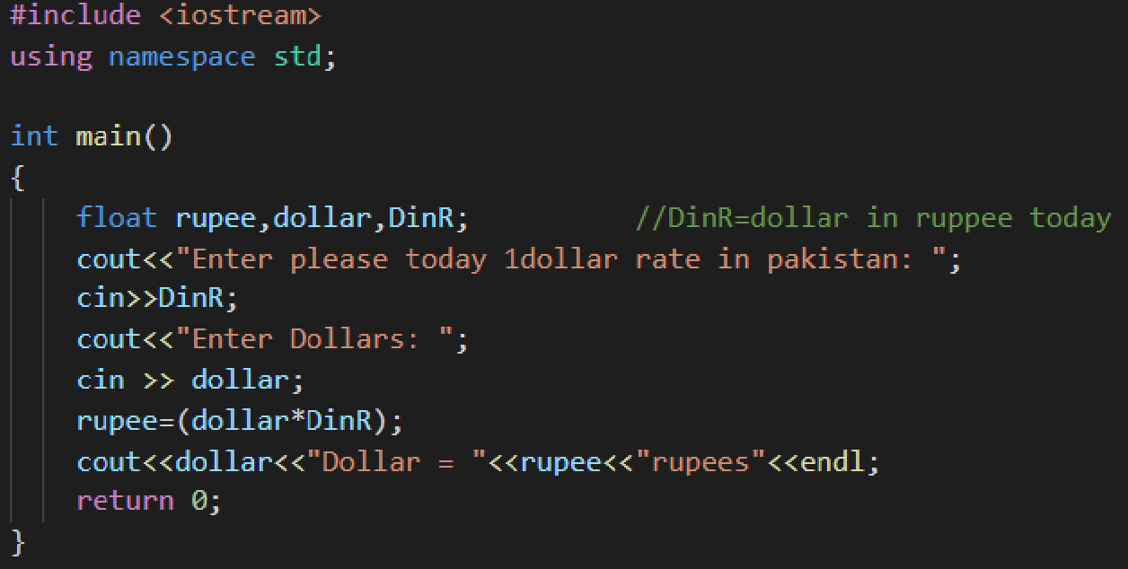

Write C++ program that will convert dollar to rupees(Dollar to Rupees Conversing Calculator).

**Output**

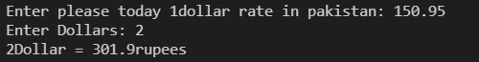

**Qno2**

Write C++ program that will convert rupees to dollar (Rupees to Dollar Conversion Calculator).

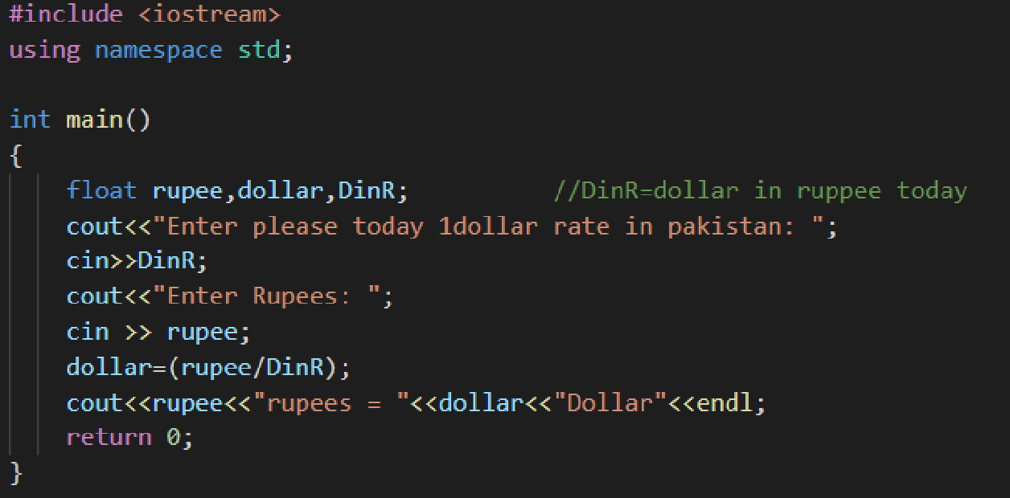

**OUTPUT**

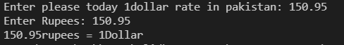

**QNO3**

Write a C++ program that will convert centigrade to Fahrenheit.

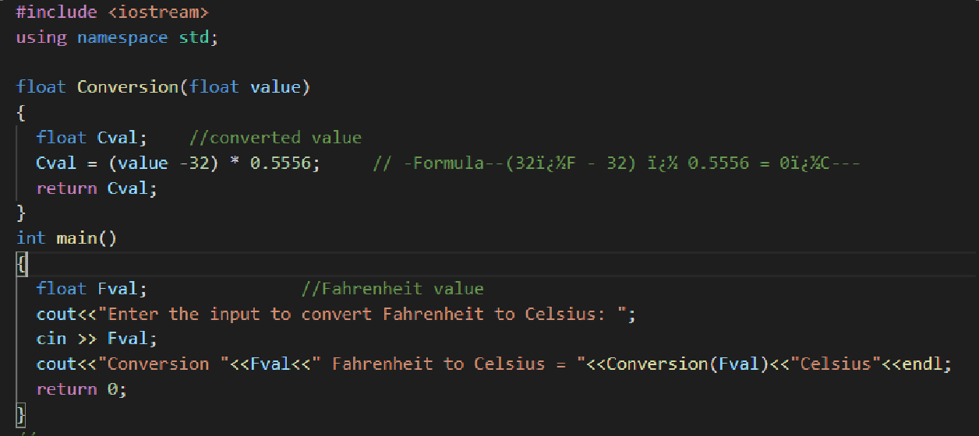

## OUTPUT QNO4

Take student name and marks of your 2nd semester from user and then generate DMC which will contain obtained marks out of total and percentage.

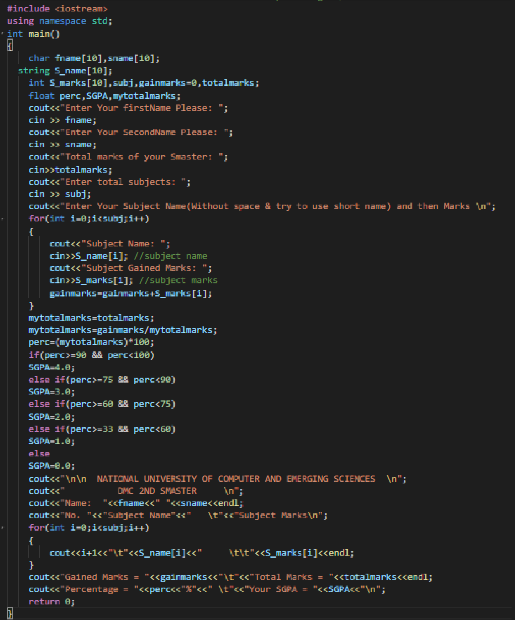

**OUTPUT:**

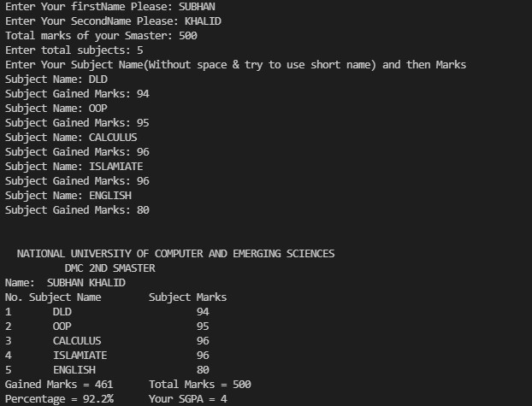

**QNO5**In lab manual 2.3 math functions (Other Math Functions) are listed in the form of tableyou all are directed to implement all these functions using C++ program.

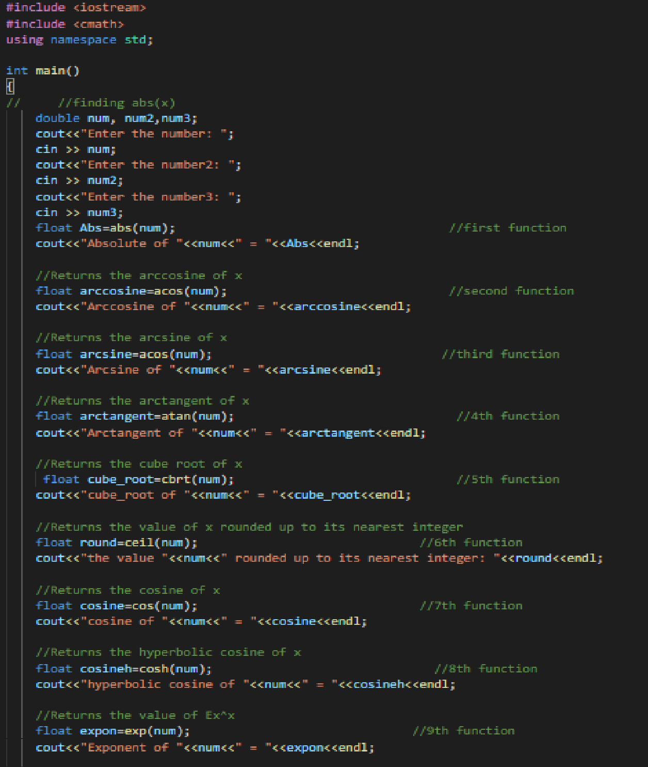

**Its next part is below for complete function**

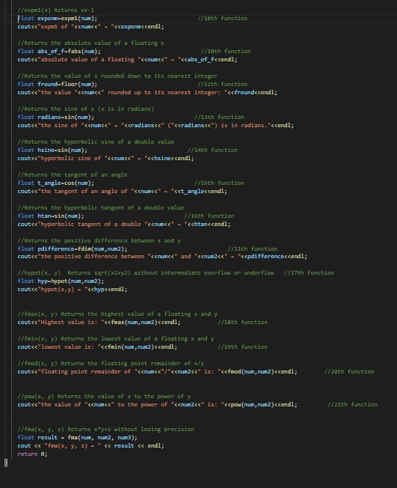

**OUTPUT**

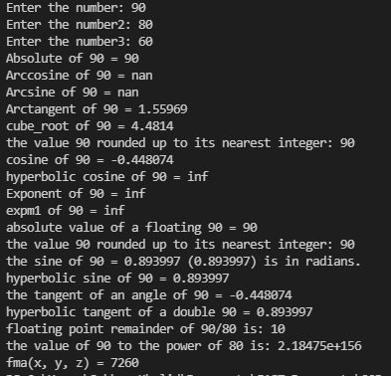

**If else:**

**Conditional Statements**

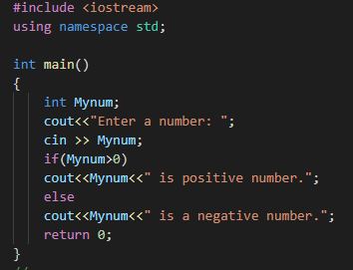

**QN01**Find positive and negative numbers using if else statement.

**OUTPUT**

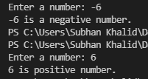

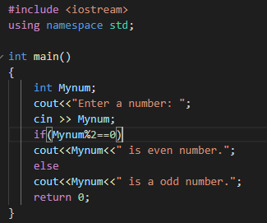

**QNO2** Find even and odd numbers using if else statement.

**OUTPUT**

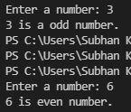

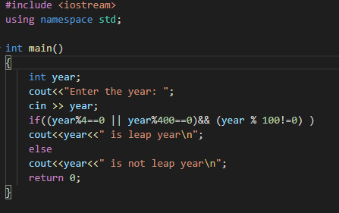

**QNO3**Find leap year using if else statement.Leap year Hints: common year has 3

65 days (feb 28 days) year%4==0 and year % 400 == 0leap year not year % 100 != 0 Leap year has 366 days (feb 29 days)

**OUTPUT**

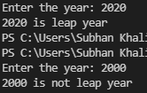

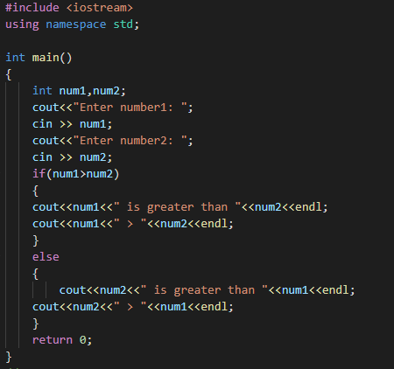

**QNO4**Write a C++ program which will get two numbers from user and find large number between them using if else statement.

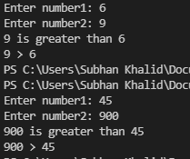

→**If-else-if else**

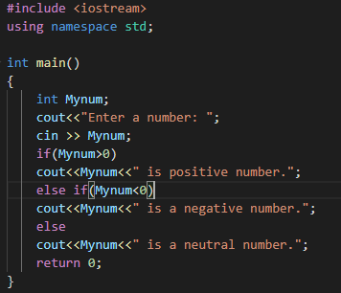

**QNO1** Find positive, negative and neutral numbers using if-else-if else

**OUTPUT**

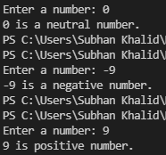

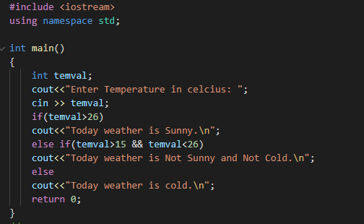

**QNO2**Take value of temperature from user and find status of weather accordingl

**OUTPUT**

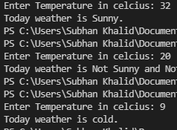

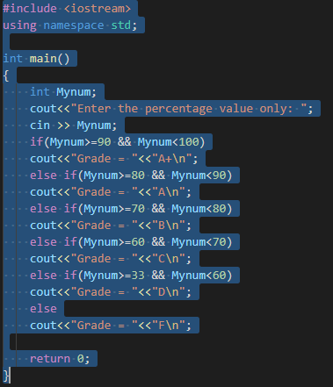

**QNO3**Take value of percentage from user and find grades based percentage value.

**OUTPUT**

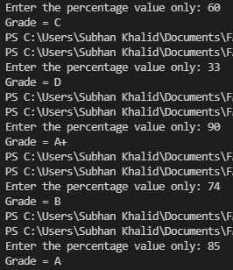

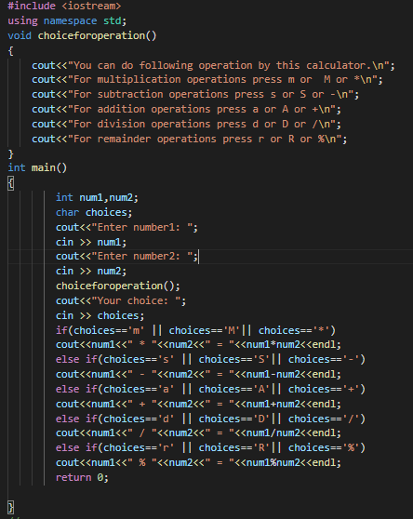

**QNO4** Make a calculator using if-else-

if else statement which perform the addition, subtraction, multiplication, divisi on and remainder operations . Take values and operator from user on runtime.

**OUTPUT**

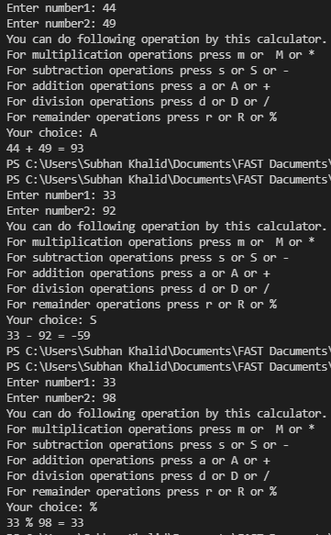

**Conditional Operator (?:)**

**QNO1**

Write a C++ program which will get two numbers from user and find large number between them using conditional operator

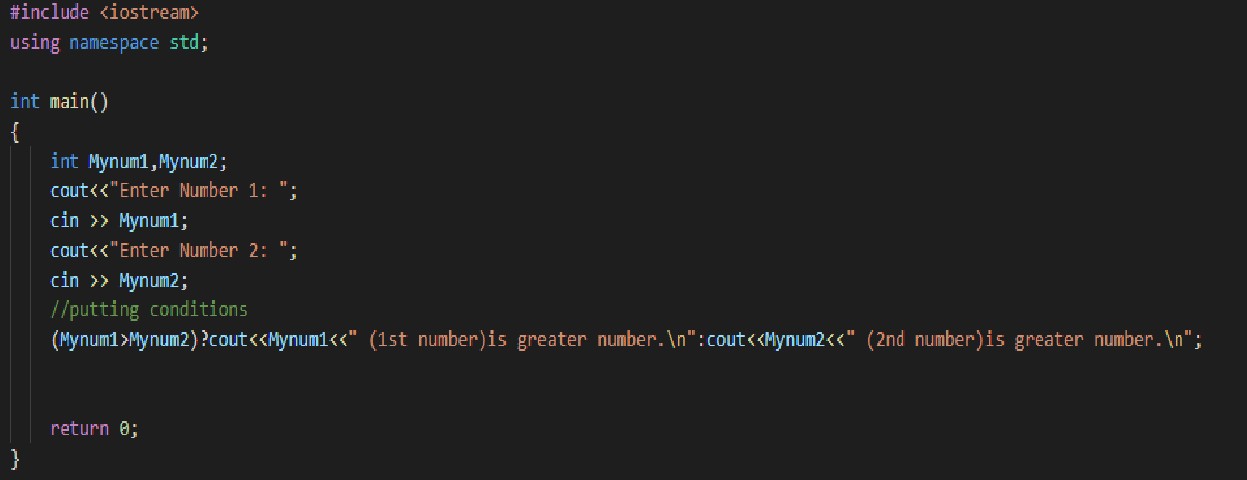

**OUTPUT**

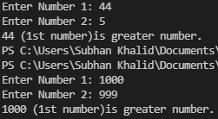

**QNO5** Find positive and negative numbers using conditional operator.

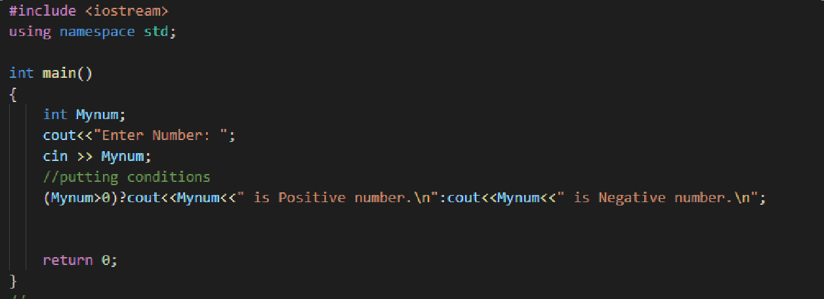

**OUTPUT**

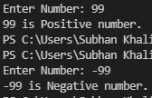

**QNO6** Find even and odd numbers using conditional operator.

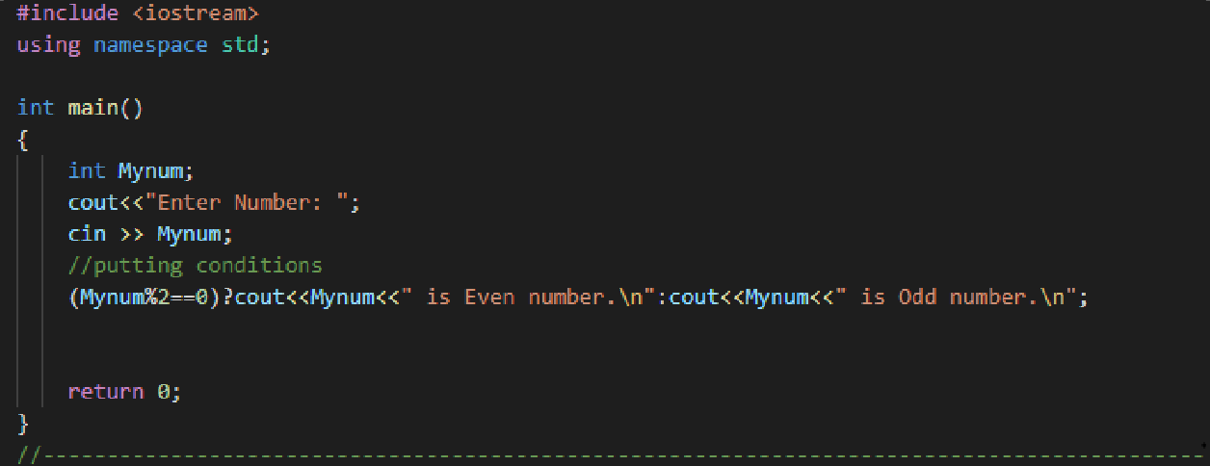

**OUTPUT**

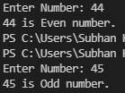

**Switch Statement**

**QNO1**Make a C++ calculator using switch statement which perform the following a ddition, subtraction, multiplication, division and remainder value. Take value at

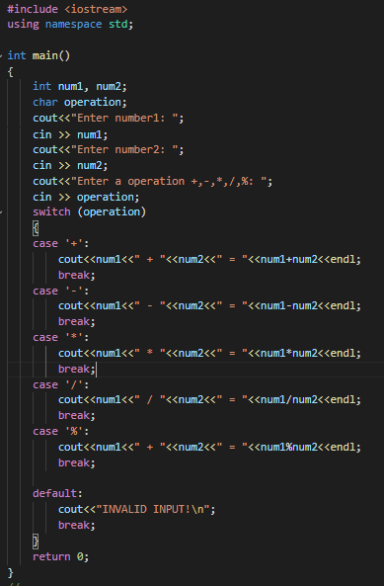

operator from user on runtime

**OUTPUT**

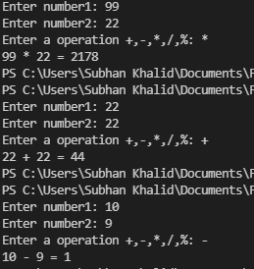

**QNO2** Write a C++ program using switch statement which get month number from user and display month name accordingly.

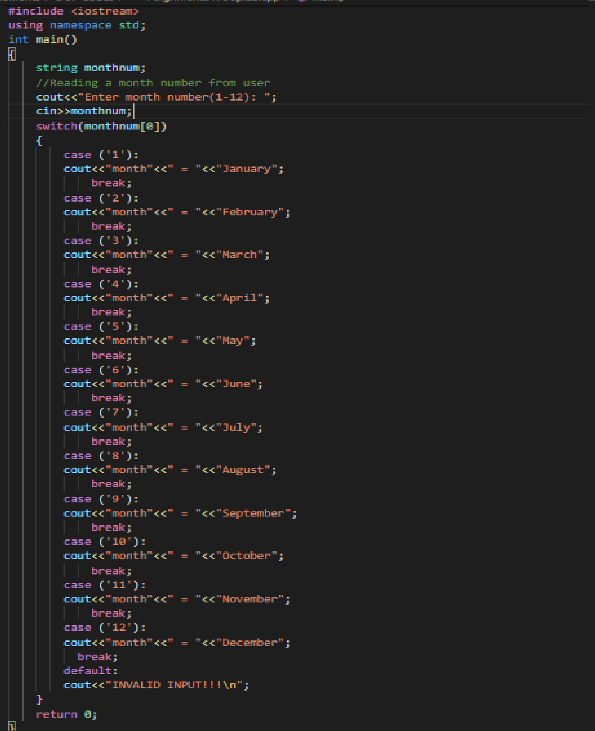

**OUTPUT**

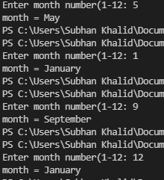

**Loops**

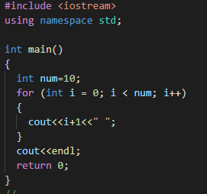

**QNO1** Write a C++ program which display first 10 number using for loop.

**OUTPUT**



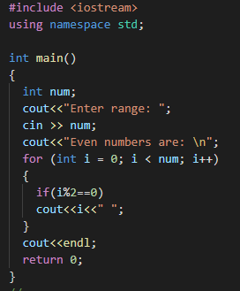

**QNO2** Write a C++ program which display even and odd number using for loop.

**OUTPUT**



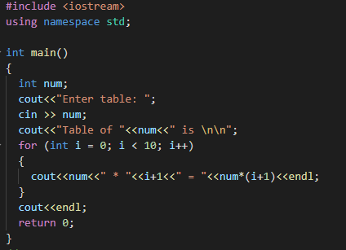

**QNO3** Take a number from user and make a table of that number using for loop

**OUTPUT**

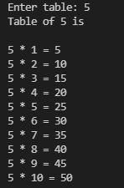

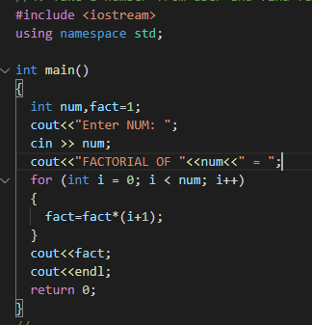

**QNO4** Take a number from user and find factorial of that number using for loop.

**OUTPUT**



**While loop**

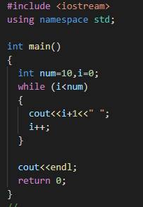

**QNO1** Write a C++ program which display first 10 number using while loop.

### OUTPUT



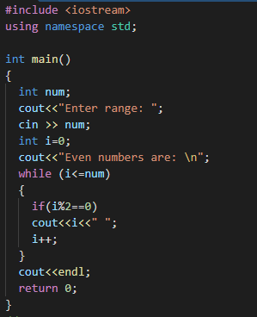

**QNO2** Write a C++ program which display even and odd number using while loop.

**OUTPUT**



**QNO5** Make a calculator using While loop

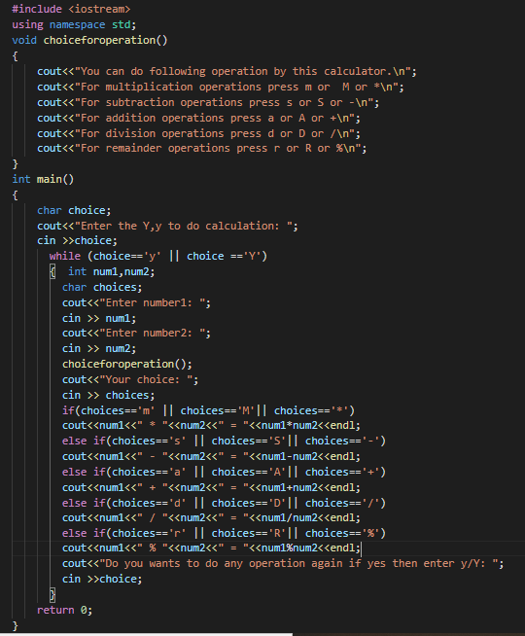

### OUTPUT

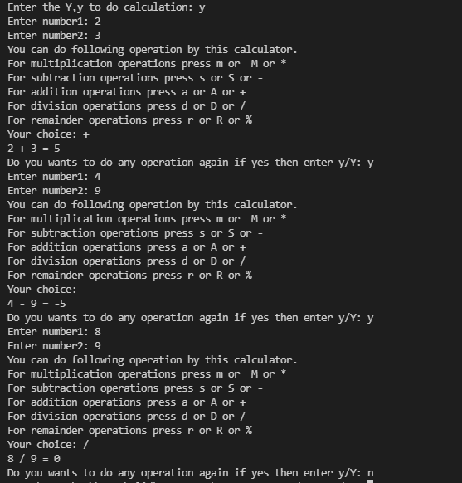

**DO-WHILE-LOOP**

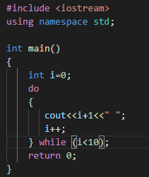

**QNO1** Write a C++ program which display first 10 number using do while loop.

**OUTPUT**



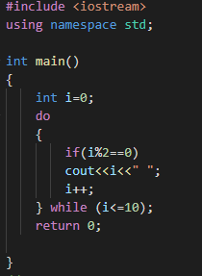

**QNO2** Write a C++ program which display even and odd number using while loop.

**OUTPUT**



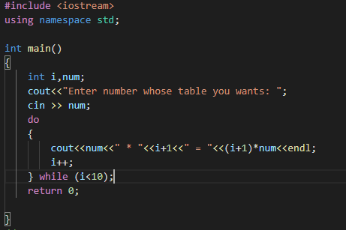

**QNO3**Take a number from user and make table of that number using do while loop

**OUTPUT**

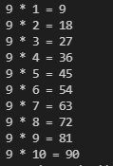

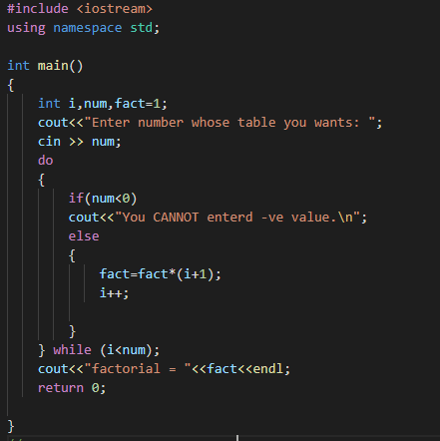

**QNO4**Take number from user, find factorial of that number using do while loop.

**OUTPUT**

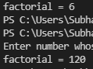

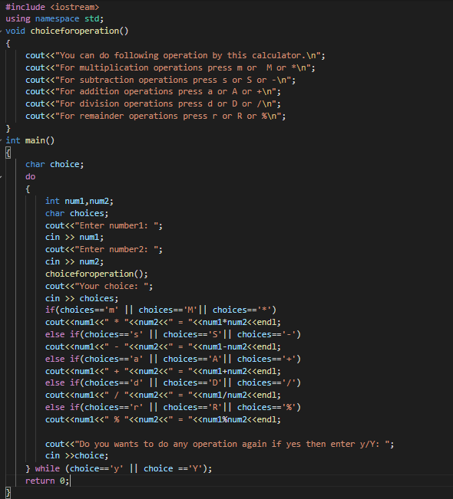

**QNO5** Make a calculator using if-else-if else statement AND do-while loop

**OUTPUT**

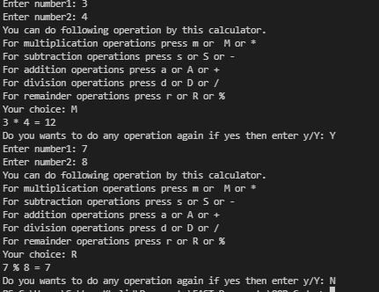

**Nested for loop**

**QNO1** DRAW

* * *

* *

*

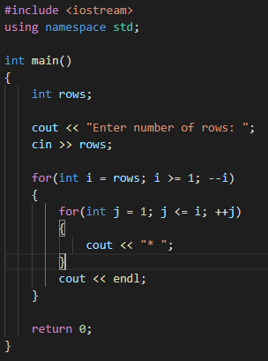

**OUTPUT**

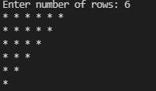

|  |  |
| --- | --- |
| **QNO2** DRAW | |
| 1 | 2 3 4 |
| 1 | 2 3 |
| 1 | 2 |
| 1 |  |

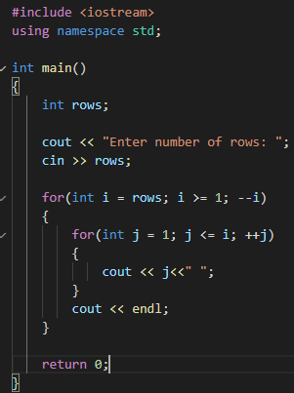

**OUTPUT**

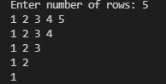

**QNO2** use of "setw" ftn DRAW

*

***

*****

*******

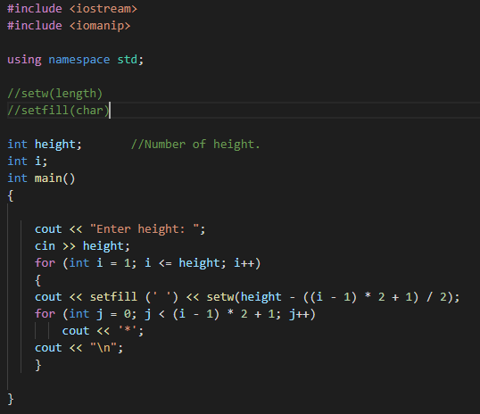

**OUTPUT**

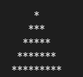

**QNO3** //Q4 DRAW

// ***********

// *********

// *******

// *****

// ***

// *

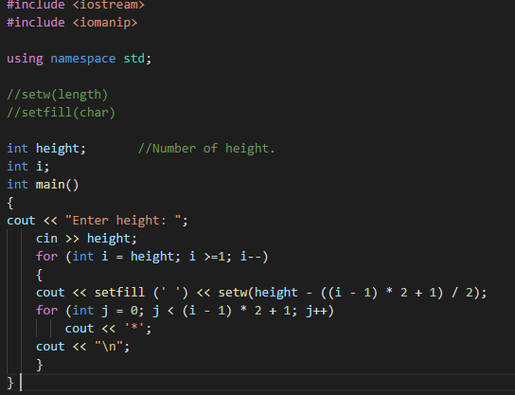

**OUTPUT**

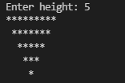

**Arrays 1D** Arrays

**QNO1**

Write a C++ program that will add two single dimensional array elements. Take values from user at runtime.

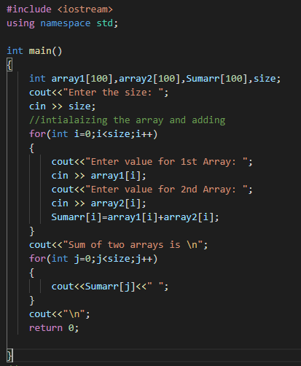

### OUTPUT

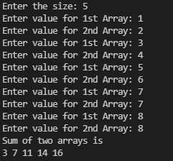

**QNO2**

How to generate random number C++, write a simple C++ program that will generate random number from 1 to 100?

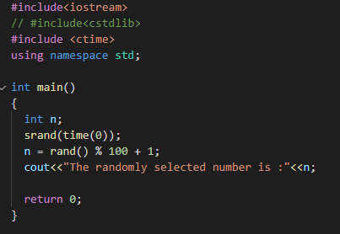

**OUTPUT**

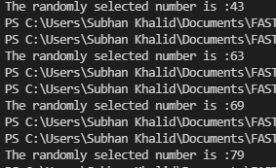

**QNO3**

Write a C++ program that will add two single dimensional arrays elements using random numbers?

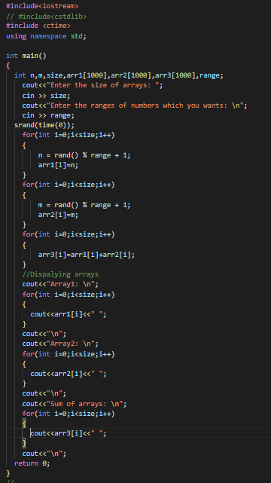

**OUTPUT**

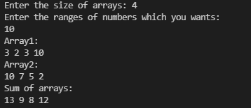

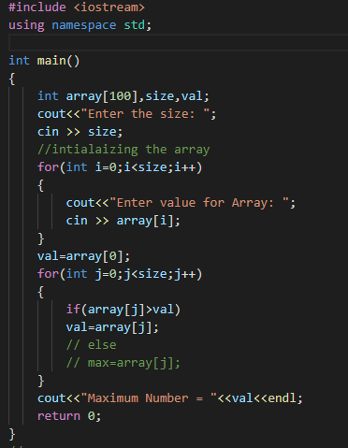

**QNO4** Write a C++ program that will find maximum number in an array?

**OUTPUT**

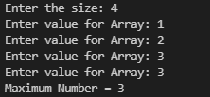

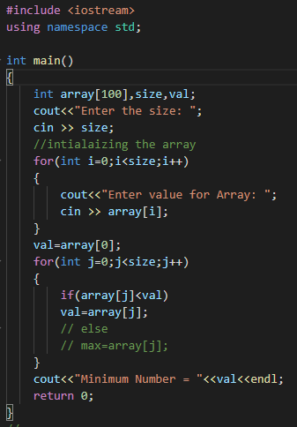

**QNO5** Write a C++ program that will find minimum number in an array?

**OUTPUT**

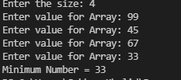

**2D** Arrays

**QNO1**

Write a C++ program that will create 2D array using random numbers and then show these values.

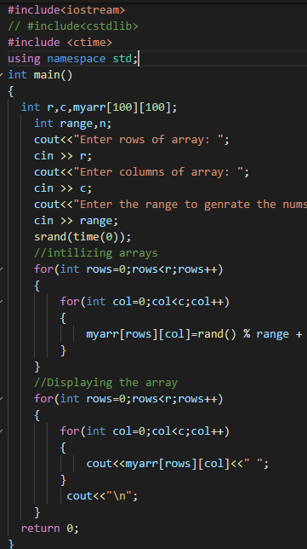

**OUTPUT**

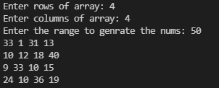

**QNO2**

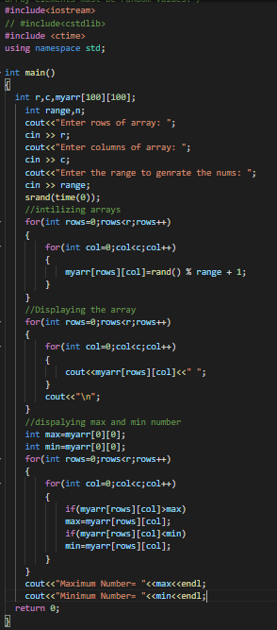

Write a C++ program that will find maximum and minimum number in 2D array. Note array elements must be random values

.

**OUTPUT**

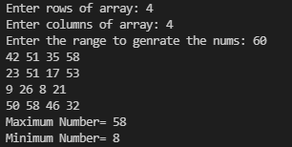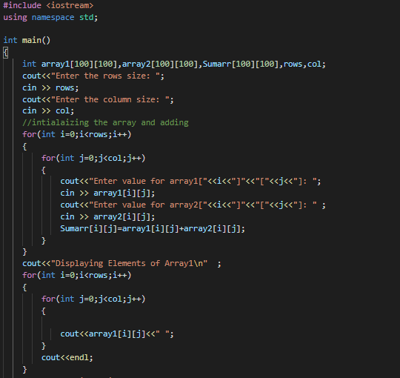

**QNO3**

Write a C++ program that will add two 2D arrays elements. Take values from user runtime. Note display values of 1st, 2nd and their resultant array.Hints: A will

be the 1st array, B will be the 2nd array and C will be resultant array.Note: Fol low Mathematics Matrix Addition Rules

**Question next part is below**

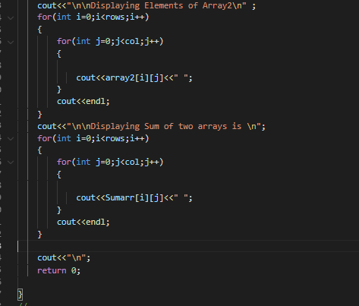

**OUTPUT**

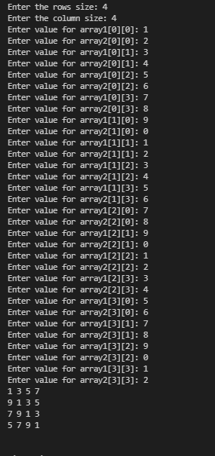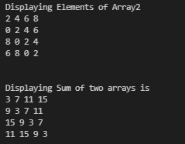

**QNO4**

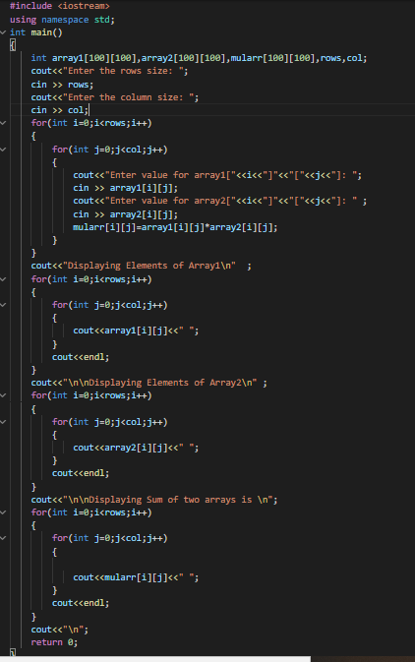

**OUTPUT**

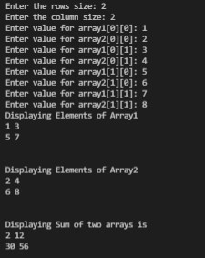

**Functions**

**QNO1**

Write function in C++ that will calculate table of a number in C++. Number must be passed from calling function as an argument to function parameters.

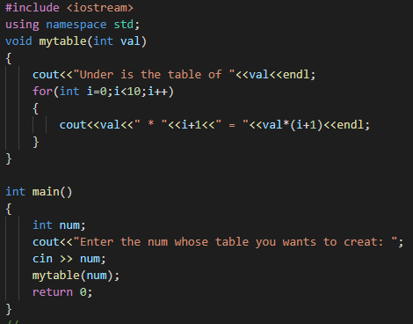

**OUTPUT**

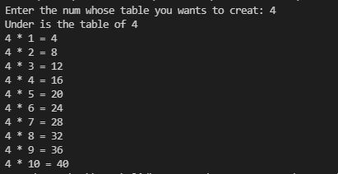

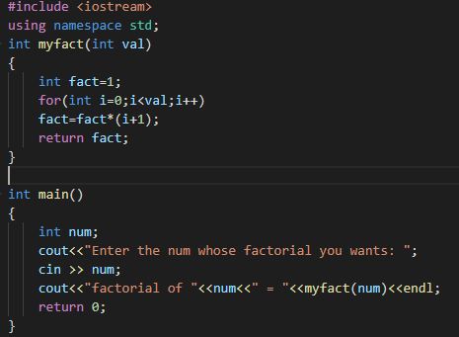

**QNO2**

Write function in C++ that will find factorial of a number. Number must be passed from calling function as an argument to function parameters.

**OUTPUT**



**QNO3**

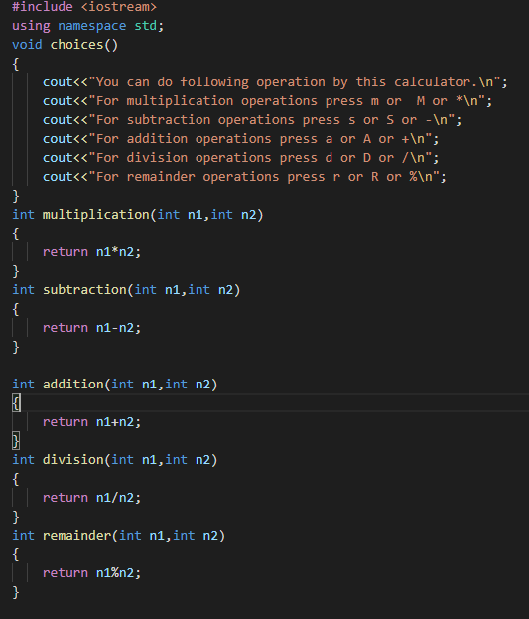

Update your calculator using functions

**Question next part is below**

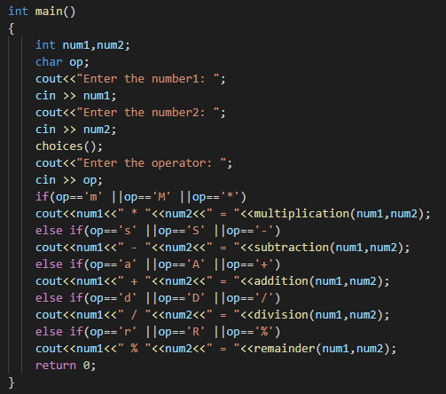

**OUTPUT**

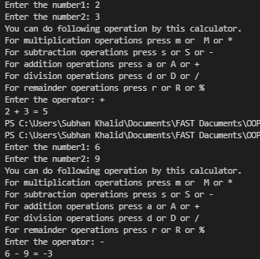

**QNO4**

Write user defined function arrayFunction() in C++ which will initialize array by taking values from user at run time and then call this function in main function which will return this array from the calling function to the called function (to

the main function) and then show all items of array in main function using loop.

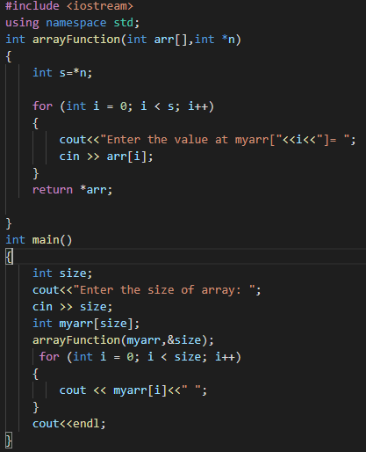

**OUTPUT**

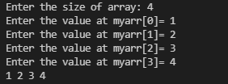

**Qno5** Type checking program

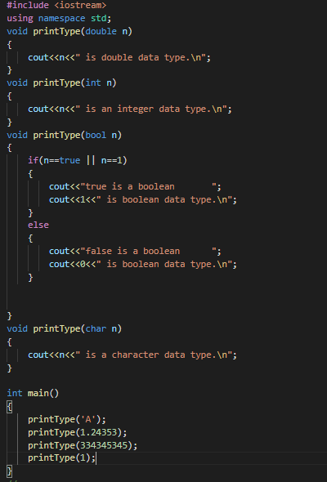

m

**OUTPUT**

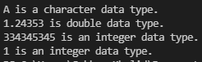

**Pointers**

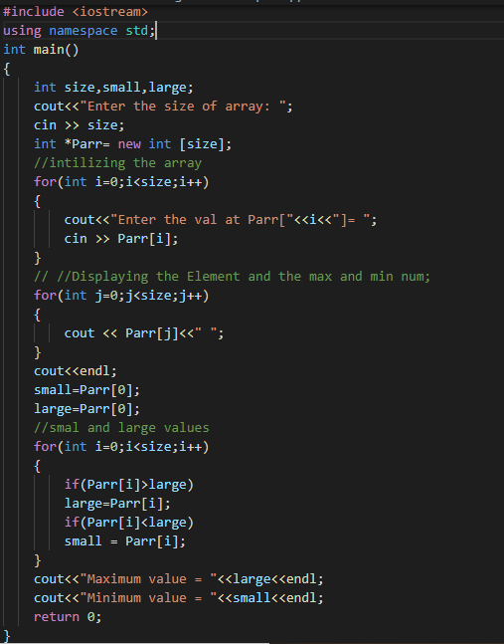

**QNO1** Write a program to input data into an array

and find out the maximum value and minimum value from array through pointer?

**OUTPUT**

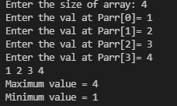

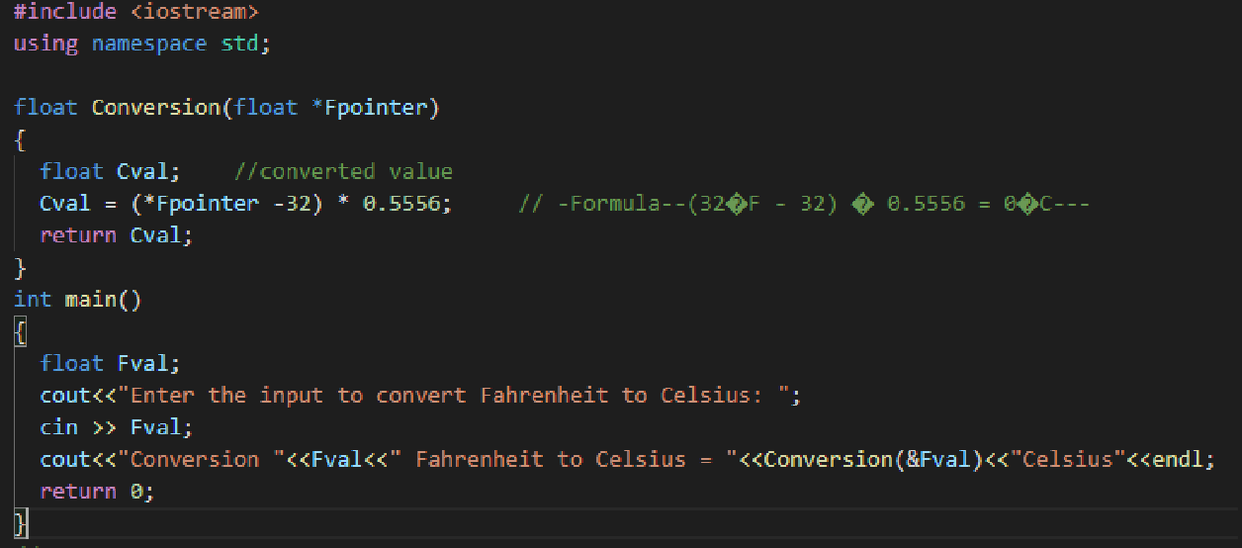

**QNO2**

Write a program to convert Fahrenheit to Celsius degrees by passing pointers as arguments to the function?

**OUTPUT**



**QNO3**

Write a program to convert kilogram into grams by passing pointers as arguments to the function?

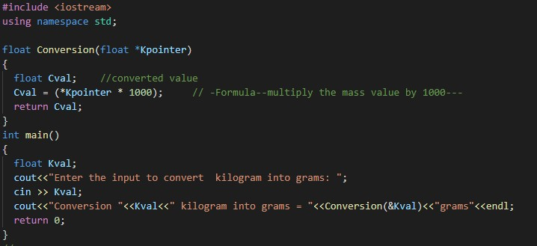

**OUTPUT**



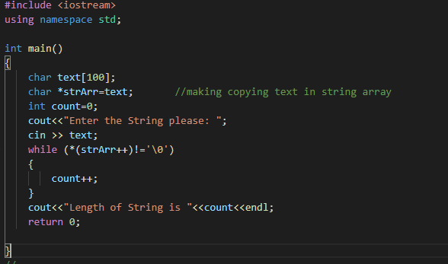

**QNO4**

Write a program to find out the length of string by using pointers?

**OUTPUT**

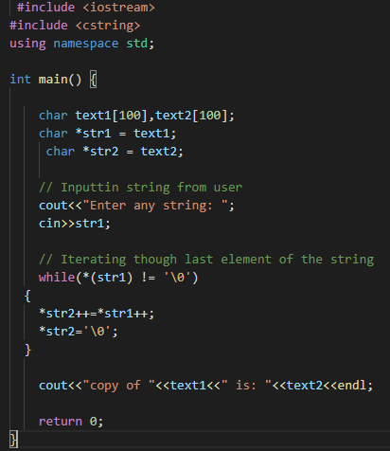

**QNO5** Write a program to copy one string to another string by using pointers?

**OUTPUT**



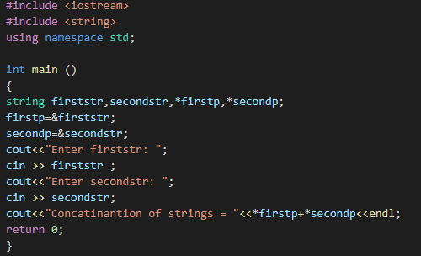

**QNO6**

Write a program to combine two strings by using pointers?

**OUTPUT**



**Structures**

**QNO1**

Create a structure called employee that contains two members: an employee number (type int) and the employee’s compensation (in dollars; type float). Ask the user to fill in this data for three employees, store three variables of type struct

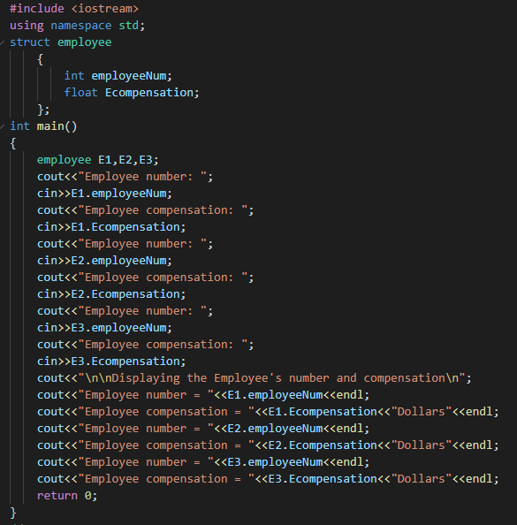

employee, and then display the information for each employee.

**OUTPUT**

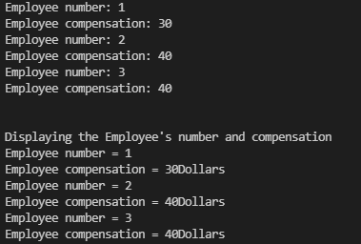

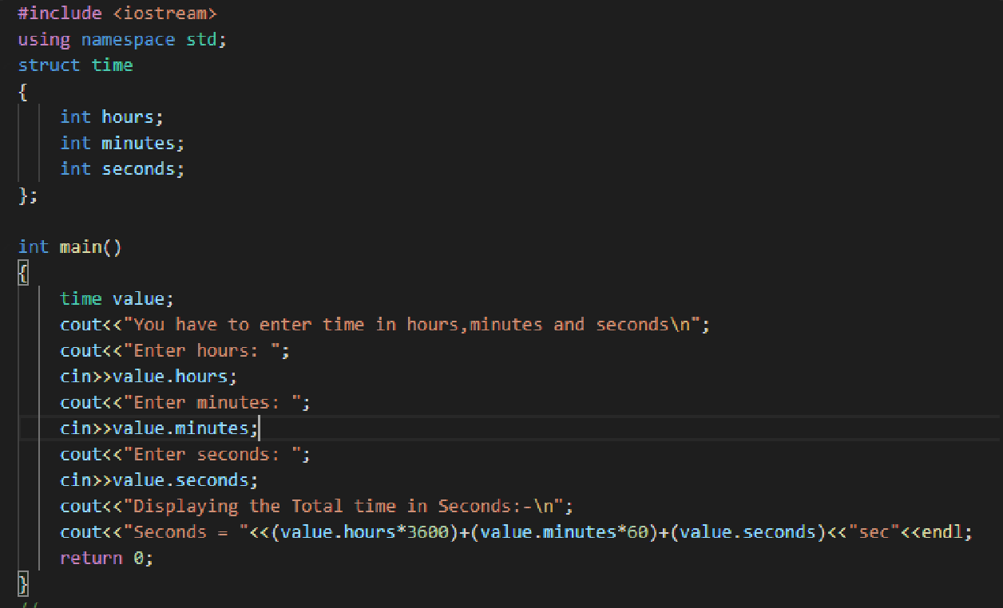

**QN02**

Create a structure called time. Its three members, all type int, should be called hours, minutes, and seconds. Write a program that prompts the user to enter time value in hours, minutes, and seconds. The program should then store the time in a variable of type struct time, and finally print out the total number of seconds.

**OUTPUT**

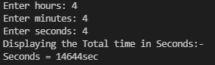

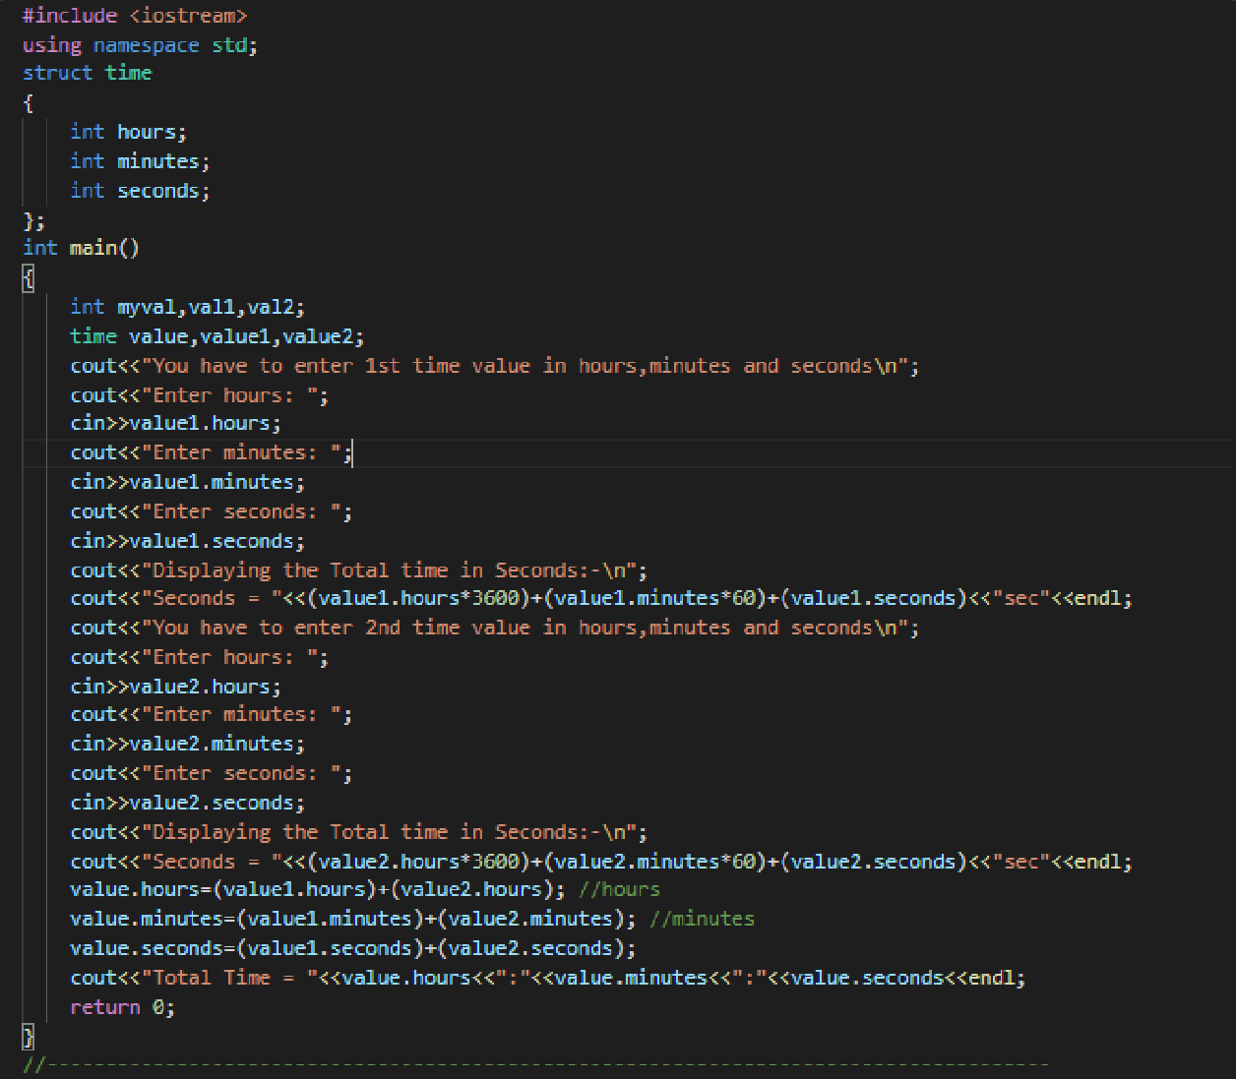

**QNO3** FOR previous question

Use the time structure displays the result in 12:59:59 (46,799sec) format

**Output**

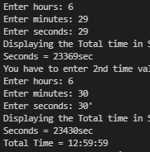

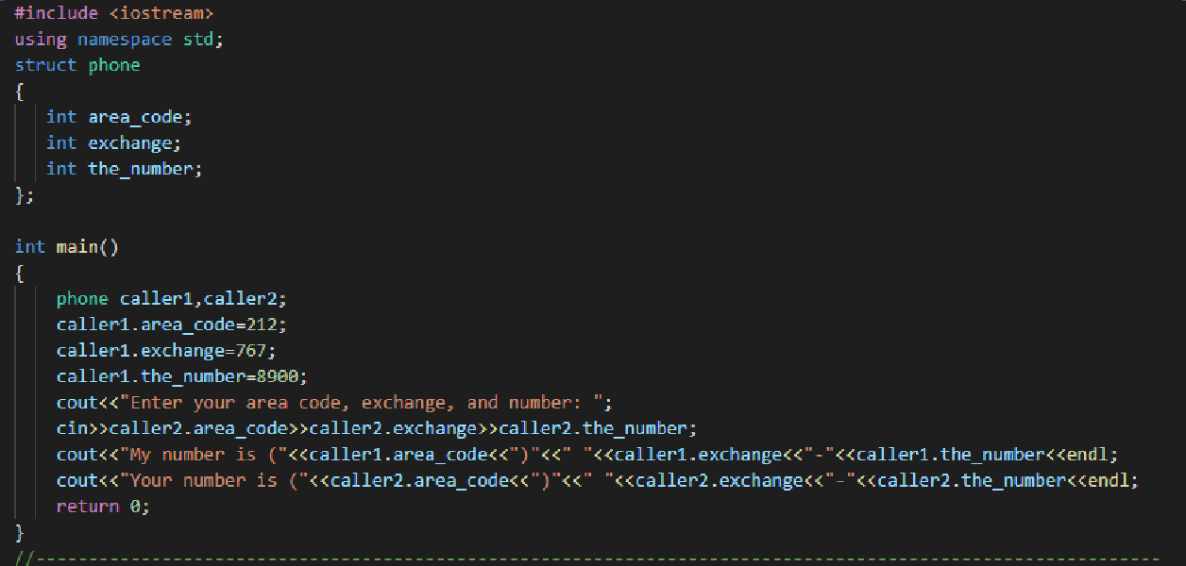

**QNO5**

The interchange might look like this: Enter your area code, exchange, and number: 415 555 1212 my number is (212) 767-8900 your number is (415) 555-1212

**OUTPUT**

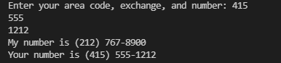

**QNO6**

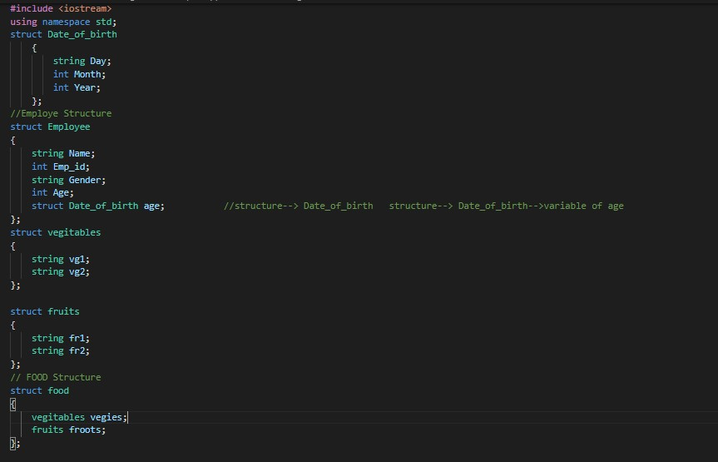

**Next part of this code is bellow**

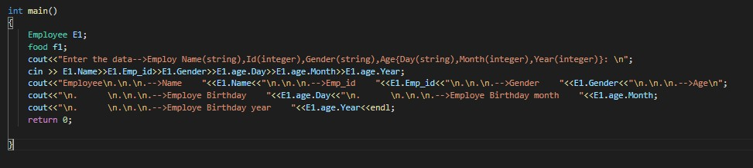

**OUTPUT**

